Structural System Design and Analysis for a Liquid Propellant Rocket

Maryland Space Grant Consortium

Summer Exchange 2019

Morgan State University

Micah Nissly

Mentors: Dr. Guangming Chen and Dr. Richard Damoah

August 9th, 2019

**Table of Contents**

Nomenclature 2

1.0 Introduction 3

2.0 Conceptual Design 3

2.1 Background 3

2.2 Design Methodology 4

2.3 Mission/Design Requirements 5

2.4 Initial Sizing 5

2.5 Conceptual Modelling 6

2.6 Configuration Selection 8

3.0 Preliminary Design 9

3.1 Aerodynamics & Stability 9

3.2 Structure 13

3.3 Sub-System Design 14

3.4 Simulation Data 16

3.5 Final Preliminary Design 16

4.0 Manufacturing Analysis 16

4.1 Airframe 16

4.2 Nosecone 17

4.3 Major Structural Elements 17

4.4 Integration 17

5.0 Tangible Design and Next Steps 17

5.1 3D Model 17

5.2 Future Work 19

6.0 Conclusion 20

Acknowledgments 20

Bibliography 21

Appendices 22

**Nomenclature**

ABS - Acrylonitrile Butadiene Styrene

ARROW – Aerospace Rocket Research for Opportunities in the Workplace

CFRP – Carbon Fiber Reinforced Polymer

CG – Center of Gravity

COTS – Commercial Off the Shelf

FEA – Finite Element Analysis

GLOW – Gross Lift Off Weight

*Isp* – Specific Impulse

MDSGC – Maryland Space Grant Consortium

MSU – Morgan State University

NAR – National Association of Rocketry

PLA – Polylactide

**1.0 Introduction**

This report documents a research project funded by the Maryland Space Grant Consortium (MDSGC) as part of the Aerospace Rocket Research for Opportunities in the Workforce (ARROW) program at Morgan State University. The project aims to complete structural design and analysis for a suborbital liquid-bipropellant rocket which will be the first in a series of three rockets to be designed, built, and launched by the ARROW team. The main objectives of this rocket are innovation, optimization, and skill development in liquid-propellant rocket engineering. This project is partnered with another MDSGC funded project focused on researching liquid fuels and designing a liquid rocket engine.

The primary objective of this rocket is to reach an apogee of 13,000 ft. The structural design will be sized to integrate with the propulsion system being designed concurrently. Rocket structural design includes the airframe, any internal structural supports, and securing the propulsion and mission subsystems. This report presents the design process used to develop the structural system and discusses the specific design chosen. It covers necessary background on launch vehicle structural design and discusses initial conceptual design processes used to establish vehicle parameters. Next, it delves into optimization and analysis techniques before discussing more detailed design choices and outlining manufacturing analysis for the rocket.

**2.0 Conceptual Design:**

**2.1 Background:**

Liquid propellant launch vehicle design is an extremely relevant field. In addition to the great strides being made commercially; for the first time, liquid propellent rockets are being designed and launched by amateurs. Amateur liquid rocket design, especially done by students, presents a unique set of challenges including limited time, budget, technical expertise, and resources. These limitations make design optimization important, as design changes and suboptimal final designs are extremely detrimental to project success.[1]

Clean sheet design presents a special challenge because there are minimal starting constraints. Commercial suborbital rockets typically use surplus engines from military applications and the rocket structures and geometry are designed around the propulsion system.[1] A clean sheet approach presents more potential for optimization, but system optimization is also more difficult due to the fewer design constraints. To resolve the issues associated with clean sheet amateur design, design criteria will be investigated.

*Design Criteria:*

While there are many factors that are considered in rocket performance; for suborbital rockets, the goal for design optimization is maximizing the apogee. For structural systems design, the optimization criteria chosen for maximizing apogee were gross lift-off weight (GLOW), mass ratio, aerodynamic drag, and simplicity.

*GLOW* effects the necessary propulsion system size to lift the rocket. A rocket may be well optimized structurally, but if it is oversized for its mission, the propulsion system will need to be larger and more complicated, leading to added project costs. Therefore, GLOW should be minimized.

*Mass Ratio* is a variable that relates to the degree that a rocket’s structure has been optimized. It is defined as $MR= \frac{m_{0}}{m_{f}}$ where $m_{0}$ is the liftoff mass and $m_{f}$ is the burnout mass (which is the dry mass). The importance of maximizing mass ratio can be seen by examining the Tsiolkovsky Rocket Equation:

$∆v=I_{sp}∙g_{0}∙\ln\left(\frac{m_{0}}{m_{f}}\right)$ (Eq. 1)

$∆v$ correlates to the apogee and is directly related to the natural log of the mass ratio. This relationship shows the sensitivity of a rocket’s performance to mass ratio. Structural optimization to minimize dry mass is therefore crucial for good performance.

*Drag* is a parasitic force caused by a rocket’s interaction with the atmosphere. Large drag will both hurt performance as well as put added stress on structural components, which is undesirable. The equation for calculating the drag force is given in Eq. 2.

$Drag= C_{D}\frac{1}{2}ρAu^{2}$ (Eq. 2)

Drag is dependent on both the coefficient of drag ($C_{D}$) and the reference area ($A$). These two factors should be minimized by optimizing the rockets shape for a low coefficient of drag and limiting the rocket’s diameter to minimize the reference area.

The importance of these criteria can be seen by applying Newton’s second law to a rocket in flight at zero angle of attack.

$m∙a=Thrust-Drag-mg$ (Eq. 3)

Both gravitational and drag forces counter the thrust provided by a rocket’s engine and hinder vertical acceleration, so should thus be minimized. While the relationships between these forces are quite complex in real flight, this simplified version of the problem defines what variables are important to consider when doing more complex analysis.

Rocket design is a complex systems engineering problem.[1] Every design decision impacts GLOW and any relating to the airframe and rocket dimensions impact drag. Additionally, many design variables are coupled and don’t have fully defined relationships, so one-at-a-time variable optimization, does not guarantee system optimization. Because of this, designing a good rocket becomes a difficult problem. As a result, the process of analysis is important, and sophisticated tools must be used to implement multi-variable analysis with the utilization of tradeoff studies and iterative design.

**2.2 Design Methodology**

The focus of conceptual design was choosing a system capable of meeting the mission requirements within mass, cost, and scheduling restraints as well as successful integration with the propulsion system. The diagram below describes the approach used to reach a conceptual design:

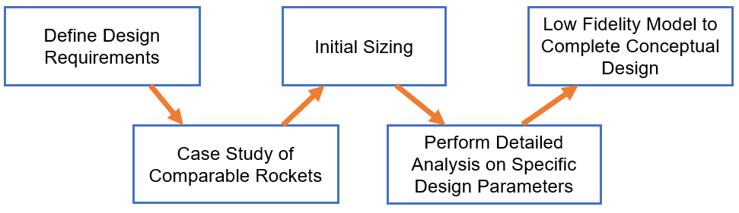

*Figure 1: Design Methodology*

After defining design requirements, it was important to look at comparable rockets that had been built to bridge the gap of technical expertise in rocket engineering. After that, initial sizing was completed using data from the case study as well as verification from a low fidelity OpenRocket model.

**2.3 Mission and Design Requirements**

The rocket will be liquid powered and designed to have an apogee of 13,000 ft. In addition, the rocket must meet all safety requirements and must be designed such that it can be manufactured with the resources available at Morgan State University by students.

It is very important that the rocket is sized to be integrated with the liquid engine currently being designed. The rocket must be large enough to hold all propulsion elements and other necessary subsystems, but light enough to reach the target apogee.

**2.4 Sizing**

Many considerations are necessary when doing initial rocket sizing. The purpose of initial sizing was to get rough dimensional estimates to work from during the design process. A case study was conducted on comparable rockets to determine a range of reasonable values for rocket length and diameter. Then, early propulsion data and preliminary modelling in OpenRocket were used to validate initial size parameters and inform selection.

Comparable rockets had diameters mostly in the range of 6-10 inches. To obtain more specific sizing parameters, consultation with the propulsion system design was necessary. The dimensions of the propulsion system were the primary drivers for the rocket’s diameter. An outer diameter of 7 inches was deemed large enough to house the propulsion system based on preliminary nozzle calculations and system length estimations.

Rocket length is driven by the combined lengths of the propulsion system and other mission subsystems. Comparable rockets had lengths mostly in the range of 10-18 feet. To estimate the rocket’s length, subsystems were identified and their lengths estimated. A list of mission systems with preliminary length estimations is given in *Table 1*. An OpenRocket model was used for this purpose and edited as the propulsion and mission subsystems were more clearly defined. Based on early estimates, a length of 12-15 ft, will be used. This gives a Length-to-Diameter ratio in the range of 20.6 - 25.7, which is similar to the L/D of rockets examined in the case study. The large length range is primarily due to the potential variability in the propulsion system length based on design decisions.

*Table 1: Subsystem Length Estimates*

|  |  |
| --- | --- |
| Subsystem | Length Estimation |
| Avionics | 12 inches |
| Recovery | 15 inches |
| Propulsion | 90 inches |

**2.5 Concept Modelling**

While a rough initial size was determined, the design needed to move from guesswork based on similar designs to rough analysis. Typically, structural systems are designed around propulsion systems, but due to the unique case of concurrent development in this project, there needed to be a way to verify and refine sizing without a complete propulsion system to base decisions on.

OpenRocket is an open source rocket design and simulation tool that is commonly used in the amateur rocketry community. It allows for input of rocket geometry, masses, and engine specifications and performs a six-degree-of-freedom trajectory simulation. An early OpenRocket model for this rocket is shown in *Figure 2*. The gray section represents the propulsion system.

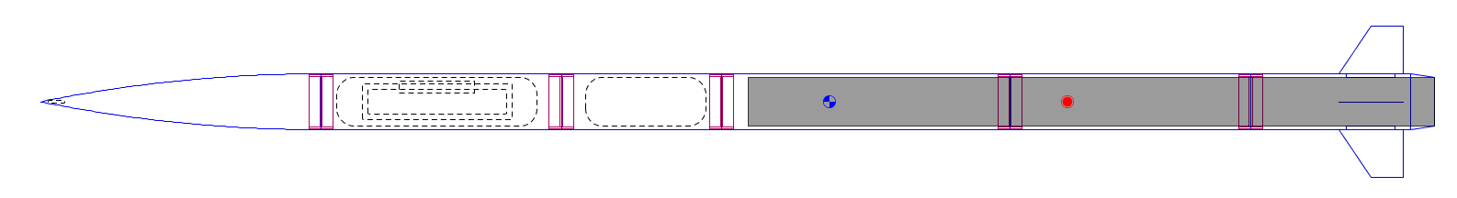

*Figure 2: Early OpenRocket diagram*

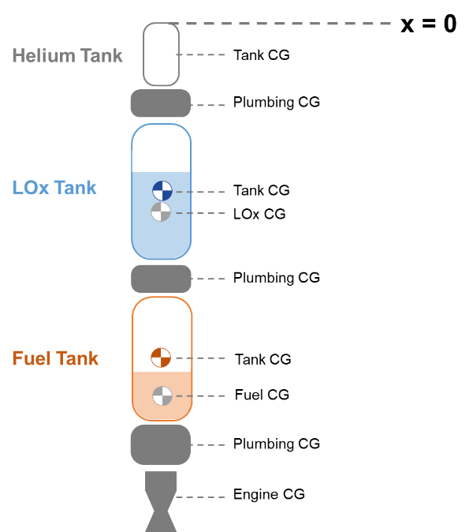*Engine Simulation:*

Because of the lack of a detailed propulsion system, a python script was written to take propulsion data and generate engine files for use in simulation. This script was developed from a script used by the Portland State Aerospace Society.[x] The mass model was changed to be accurate to a Dynamic Pressure Regulation (DPR) system (external pressurization tank), calculations for tank masses were made more robust, and batch engine generation based on variable parameters was added.

The script accepts user inputs for system geometry, weight estimates and basic propulsion data and performs necessary calculations and generated engine files for a series of different burn times which were also inputted by the user. The script used that information to calculate total propulsion system length including propellant tank geometry and generated an engine file which denotes thrust and center of mass as a function of time. The mass model used is given in *Figure 3*.

*Figure 3: Liquid Engine Mass Model*

*Calculations:*

First, total propellant mass flow rate was calculated using the thrust and $I_{sp}$. Then, mass flow rates for the oxidizer and fuel were found using the O/F ratio. Finally, mass values for oxidizer and fuel were calculated using the burn time.

$\dot{m}= \frac{Thrust}{g_{0}∙I_{sp}} →{\dot{m}}_{ox}=\frac{\dot{m}}{1+\left(\frac{1}{OF}\right)}, {\dot{m}}_{fuel}= \frac{\dot{m}}{1+OF}$ (Eq. 4-6)

$m_{ox}={\dot{m}}_{ox}∙\left(Burn Time\right), m_{fuel}= {\dot{m}}_{fuel}∙(Burn Time)$ (Eq. 7-8)

Next, propellant and Helium tank thicknesses were calculated using the tank radius and pressure with a factor of safety of 1.5. The tank material was assumed to be 6061 Aluminum, which is common for propellant tanks. A design stress was calculated and used to find required thickness based on the experienced hoop stress at the tank’s operating pressure.

$σ_{design}= \frac{σ_{yield}}{FOS}, t_{tank}=\frac{P∙r_{tank}}{σ_{design}}$ (Eq. 9-10)

The thickness calculations use assumptions for thin-walled pressure vessels, so $r_{tank}>10∙t_{tank}$ was a requirement. Next, using the oxidizer and fuel masses and densities, propellant volumes were calculated. The helium tank volume necessary to maintain constant propellant tank pressure.

$V_{He}=V_{prop}{\left(\frac{P_{prop}}{P_{He,i}-P_{He,f}}\right)}^{\frac{1}{γ}}$ (Eq. 11)

$γ$ is the ratio of the specific heats for Helium, 1.67. Tank lengths were calculated using the volumes and cross-sectional area. Cylindrical tanks were assumed for simplicity.

$l_{tank}=\frac{V_{tank}}{π∙r_{tank}^{2}}$ (Eq. 12)

Using estimates for the lengths of the engine, plumbing sections, and the calculated tank lengths, a total propulsion system length was calculated.

$l_{tot}=l_{He Tank}+l_{plumbing,1}+l_{LOx Tank}+l_{plumbing,2}+l_{Fuel Tank}+l_{plumbing,3}+l_{Eng}$ (Eq. 13)

Tank masses were calculated based on the previously determined geometries and the density of 6061 Aluminum.

$V_{tank shell}=π∙\left(r_{o}^{2}-r_{i}^{2}\right)∙l + 2π∙r_{i}^{2} → m_{tank shell}= {ρ_{Al}∙V}_{tank shell}$ (Eq. 14-15)

Total propulsion system dry mass was calculated by summing the masses of all components.

$m_{Dry}= m_{Eng}+ m_{Plumb1}+ m_{Fuel Tank}+ m_{Plumb2}+ m_{LOx Tank}+ m_{Plumb3}+ m_{He Tank}$ (Eq. 16)

The dry center of gravity was calculated based on the mass model in *Figure 3*.

+ (Eq. 17)

Finally, the CG as a function of time, including the propellant masses was calculated. The CG of the propellants assumed a constant mass flow rate.

$x_{CG}(t)= \frac{1}{m\left(t\right)}(m_{dry}∙x_{CG,dry}+m_{LOx}\left(t\right)∙x_{CG,LOx}\left(t\right)+m_{Fuel}\left(t\right)∙x_{CG,Fuel}\left(t\right))$ (Eq. 18)

The total impulse of the system was calculated assuming constant thrust for the duration of the burn time.

$I_{tot}=Thrust∙Burn time$ (Eq. 19)

Additionally, the NAR letter code for the rocket was determined based on the total impulse.

A sample session of the engine simulation script is documented in Appendix A. This engine simulation served two purposes. First, it allows for examination of engine size for various propellant combinations and burn times. This informed the propulsion system design as well as validating the preliminary sizing of the rocket. Second, it allowed for flight simulations, helping to determine which propellants and burn times would be required to reach the target apogee. The simulation was initially tested with eight propellant combinations selected by the propulsion design: LOx and RP-1, LOx and Ethanol, LOx and Liquid Methane, LOx and Liquid Hydrogen, LOx and UDMH, FLOx and RP-1, Liquid Fluorine and Liquid Hydrogen, and Dinitrogen Tetroxide and RP-1. These combinations were used to generate engines with burn times varying from 5-15 seconds, which were then compared based on system length and max apogee.

The propulsion design chose the combination of LOx and Ethanol for further development, and this combination, specifically at a 10s burn time was used for modelling and airframe sizing for the remainder of the project. Once more detailed design choices are made with regards to the propulsion system, specific sizing will need to be adjusted, and analysis reworked.

**2.6 Configuration Selection**

The final conceptual configuration for the rocket is shown in *Figure 4*. The recovery subsystem will be a two-bay dual deployment system with the drogue parachute, that will deploy at apogee, housed in the nosecone, and the main parachute housed aft of the avionics bay. The avionics bay will house communication and flight data electronics and serve to activate gas generators for recovery deployment. The high-pressure helium tank and propellant tanks will be housed in airframe sections below, with several tank and plumbing access sections with removable airframe pieces. Finally, the fin can will house the engine.

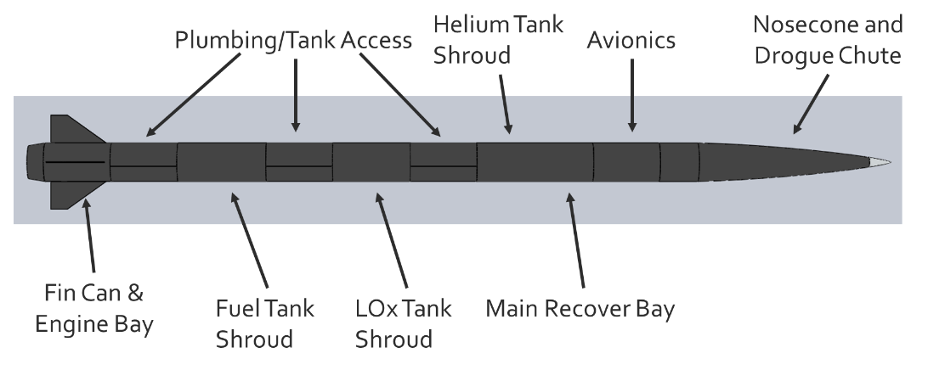

*Figure 4: Rocket Configuration Diagram*

**3.0 Preliminary Design:**

After establishing the general characteristics of the rocket, airframe shape and internal structure sizing needed to be determined. This included aerodynamic analysis, weighing structural tradeoffs, calculation of forces on the rocket in flight, and low-level structural analysis. Design decisions were guided by the optimization criteria set up in the conceptual design phase.

**3.1 Aerodynamics & Stability**

*Nosecone:*

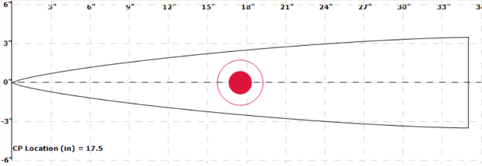The purpose of the nosecone is to minimize aerodynamic drag of the rocket. The nosecone is the first part of the rocket to interact with the air, so good design is important to performance. There are two main parameters that define a nosecone: shape and fineness ratio.

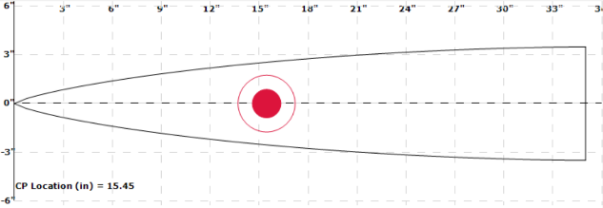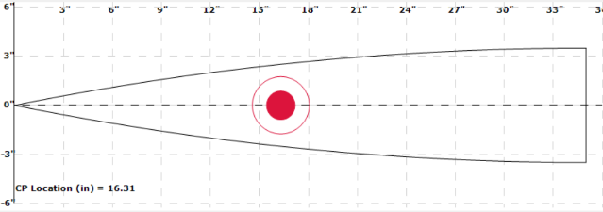A nosecone’s shape is a solid of revolution and can be defined by a curve that is rotated about an axis. The ideal nosecone shape for performance is dependent on the operational speed of the rocket. For low speeds (subsonic), the ideal nosecone shape is rounded, and a parabolic shape is typically used. For transonic and supersonic speeds, the ideal shape is pointed. There are several different shapes that are commonly used including Conical, Ogive, Von Karman, and Haack Series.

Fineness ratio is the ratio of the length of a nosecone to its diameter. Fineness ratios of 4 or 5 are typically used. Longer nosecones experience less drag due to a decrease in wave drag, but require more material, so design becomes a tradeoff between reducing drag and reducing weight.

*Figure 5: Tested Nosecone Profiles (top to bottom): Tangent Ogive, Von Karman, LV Haack*

To determine the nosecone for this rocket, drag analysis was completed in the operational velocity range. Ogive, Von Karman, and Least-Volume Haack shapes, shown in *Figure 5*, were tested with fineness ratios of 4 and 5 using the software RASAero II. The coefficients of drag plotted against MACH number are shown in *Figure 6*.

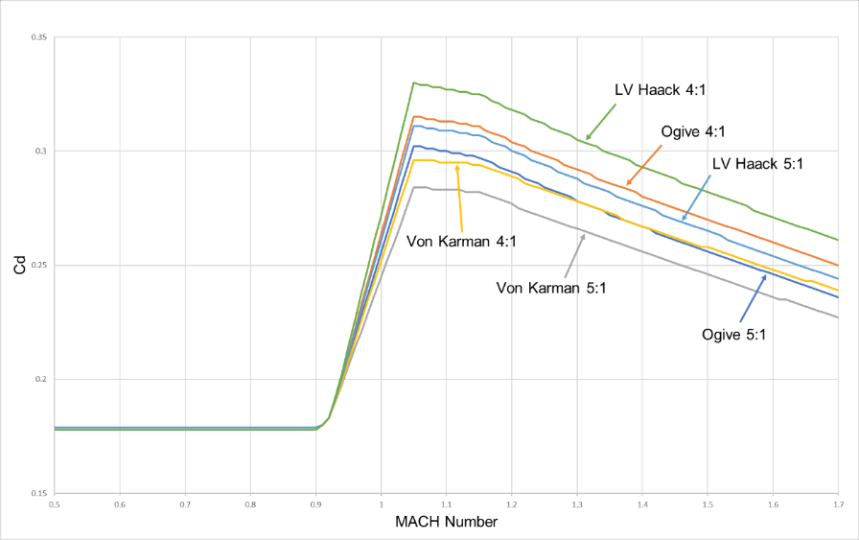

*Figure 6: Nosecone Drag Analysis*

Preliminary simulations show the rocket will be operating largely in the transonic region (MACH 0.8-1.2) and on the low end of the supersonic region (>MACH 1.2). The data shows a decrease in drag with an increase in fineness ratio across all three shapes, as expected. The Von Karman shape had the best drag performance out of the 3 shapes. Selecting between a 4:1 and a 5:1 Von Karman nosecone was a tradeoff between mass reduction and drag reduction, and ultimately the 5:1 Von Karman curve was selected because the additional mass was small relative to the drag savings. Another consideration when choosing fineness ratio is manufacturability and fragility at higher ratios, but a 5:1 ratio is not large enough to have significant issues in that regard.

An additional feature that will be incorporated in the nosecone is a 3.5-inch cylindrical section at the base of the nosecone that will allow for coupler attachment. This section was opted for over a traditional shoulder because of the specific needs of the drogue parachute and recovery hardware housed in the nosecone. A diagram of the nosecone assembly is included in section 3.5.

*Fins:*

Fin design is a tradeoff between maintaining necessary stability and structural integrity while minimizing drag. Fins provide passive guidance to the rocket by creating a counteracting moment to small incident angles of attack. There are many fin design parameters that effect performance.

A 4-fin design has been selected for this rocket, because while 4 fins have increased skin and interference drag compared to 3 fins, smaller fins can be used to obtain the same stability, which is beneficial for manufacturing and structural strength. Additionally, a 4-fin design makes fin alignment easier in installation.

Several trapezoidal fin shapes were tested using CFD software and simulated with a rough OpenRocket model to analyze their effects on drag and stability. Fin size and shape are a tradeoff between increasing stability and decreasing drag. Smaller fins will not have as large of an effect on the center of pressure but will result in less drag. An off-rail stability of at least 1.5 calipers in expected flight conditions is necessary. However, increasing the stability significantly past a safe level is undesirable because it creates additional drag and can cause weathercocking, or the rocket steering into incident wind.

|  |  |
| --- | --- |
| Dimension | Value |
| Root Chord | 12 inches |
| Semi-span | 6 inches |
| Tip Chord | 5 inches |
| Sweep Length | 7 inches |
| Sweep Angle | 49.4o |

The design settled on a clipped delta fin shape with dimensions shown in *Table 2*. A diagram explaining fin dimensioning is given in *Figure 7*. Specific dimensions were chosen using iterative testing with design “rules of thumb” for guidance.

*Table 2: Fin Dimensioning*

Structural integrity is a function of fin material, thickness, shape, and cross-section. In supersonic flight, aerostatic divergence and flutter can cause fin failure. Analysis was conducted with the program FinSim to find divergence and flutter velocities for different fin materials and thicknesses. The results are shown in *Table* 3. Factors of safety were calculated by dividing the lower velocity of the two failure modes by the max velocity predicted by the current simulation (1704 ft/s). Carbon Fiber properties were from T300 CFRP.

*Table 3: Fin Aeroelasticity*

|  |  |  |  |  |
| --- | --- | --- | --- | --- |
| Material | Thickness (in) | Divergence Velocity (ft/s) | Flutter Velocity (ft/s) | FoS |
| Aluminum | 0.125 | 1009 | 1372 | 0.59 |
| Aluminum | 0.25 | 2841 | 3864 | 1.67 |
| Carbon Fiber | 0.125 | 1026 | 1396 | 0.60 |
| Carbon Fiber | 0.25 | 2889 | 3930 | 1.70 |
| Fiberglass | 0.125 | 567 | 771 | 0.33 |
| Fiberglass | 0.25 | 1595 | 2170 | 0.94 |

Based on current flight data, 0.25-inch thickness Aluminum or Carbon Fiber fins will be required. Because preliminary data was used for calculations, this decision should be reevaluated once propulsion system in completed. Important to note, the divergence and flutter velocities are calculated at sea level, and this velocity increases as altitude increases, so the estimates are conservative.

Another structural integrity consideration is recovery. Fins with a large sweep, especially extending past the bottom of the rocket are liable to be broken off in recovery. The clipped delta shape chosen avoids this issue. Fin cross-section design can help with drag reduction. Like nosecone shape, ideal cross-section is dependent on operational velocity. Additionally, manufacturability should be considered when choosing a cross-section. Several different cross-sections are common, including rectangular, rounded, airfoil, and wedge which effect fin drag. A rounded or wedge (chamfered leading and trailing edge) cross-section is optimal for this rocket.

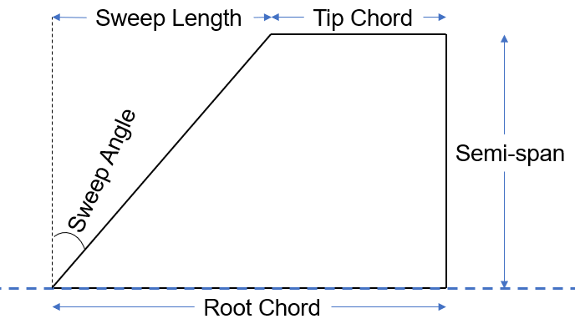 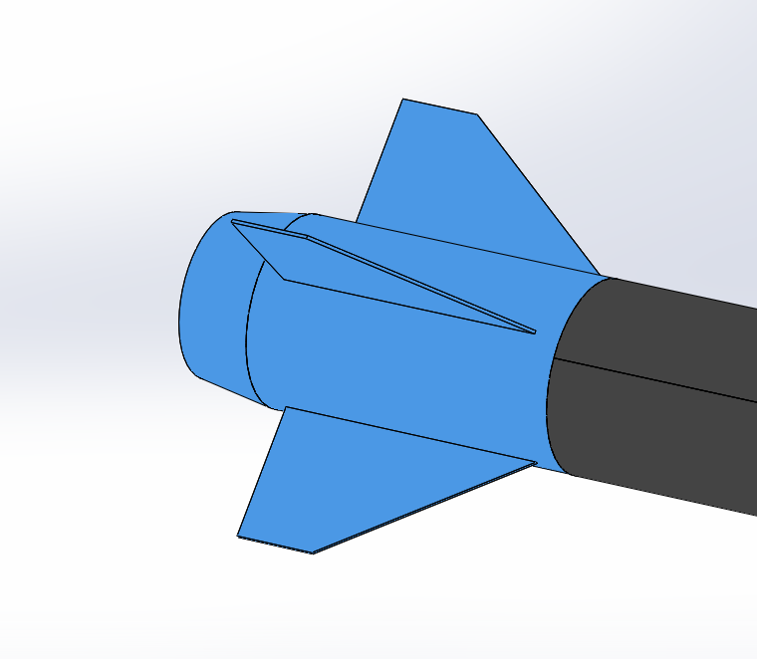

*Figure 7: Fin Dimensioning Diagram and Fin Can model*

The next design consideration is fin attachment, which is very important to think about structurally. Due to the high-powered nature of the rocket, fins should be attached via hardware, and not simply epoxy. The two options available are installing external mounting surfaces on the airframe to bolt fins in place or utilizing a through-the-wall design and mounting the fins internally. An example of both options is shown in *Figure* 8. After confirming there would be internal mounting space with the propulsion design, a through-the-wall design was selected to achieve drag savings.

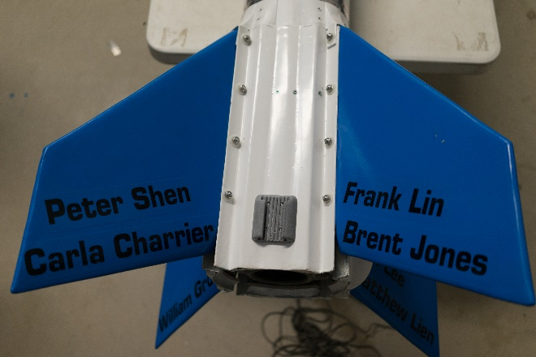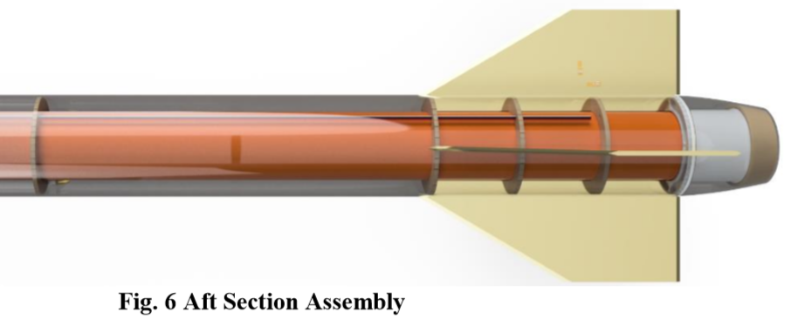

*Figure 8: Fin Mounting Methods. External – UCSD Vulcan I Rocket (left) and Through-the-Wall – Space Concordia Supersonice Rocket (right)*

*Boattail:*

Implementation of a boattail reduces a rocket’s base drag by narrowing the airframe diameter at the aft end of the rocket. Preliminary simulations show an increase of over 1,000 ft in apogee by using a 3-inch conical boattail with a 1-inch diameter reduction. *Figure 8*shows a plot of drag vs. MACH number in a model of the rocket with and without a boattail. There is a large amount of drag savings with a boattail, especially in the transonic and supersonic regions.

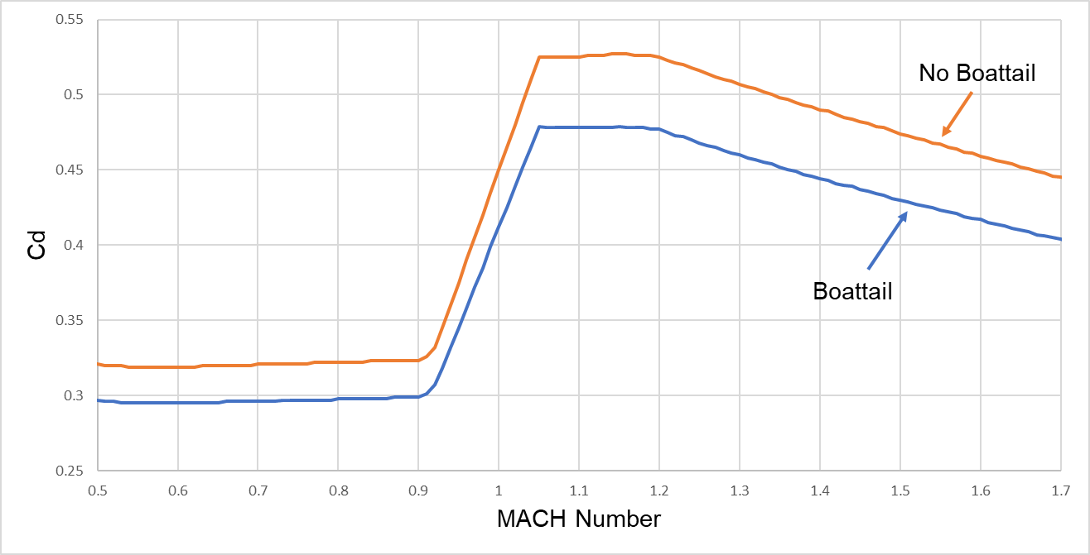

*Figure 9: Rocket drag analysis with or without boattail.*

**3.2 Structures**

A rocket’s structural design is essential for good performance. Insufficient design can result in the rocket being torn apart by aerodynamic forces, but a poorly optimized design will lead to underperformance. In the structural design process, it is important to keep in mind that every decision effects dry weight, which should be minimized.

*Structural Method and Number of Airframe Sections:*

The first crossroads reached in structural design pertains to the method of support. Three options were considered:

1. Monocoque – Structural support is entirely provided by the external shell (airframe)
2. Internal Frame – Structural support is provided by internal structural members
3. Semi-Monocoque – Support is provided by both the airframe and internal members

A semi-monocoque design was selected because of the structural flexibility it would provide. The need for flexibility with structural design in this rocket becomes clearer when designing the airframe.An airframe serves two main functions: providing a smooth external surface for contact with the surrounding air and giving the rocket structural rigidity. A rocket’s airframe must be broken into sections for manufacturing purposes and for accessibility.More airframe sections provide the rocket greater modularity which is desirable for access of mission systems, specifically to tanks, plumbing, and avionics. Additionally, standard recovery systems make use of airframe separation for parachute deployment. However, using many sections reduces a rocket’s structural rigidity and increases weight by necessitating couplers and more bulkheads.

To combat the structural instability caused by many airframe sections, internal structural rails can be used for support, especially in areas where airframe sections may need to be removed for tank and plumbing access. This use of rails is common in liquid propellant rockets. A layout diagram of the structural configuration is given in *Figure 10*.

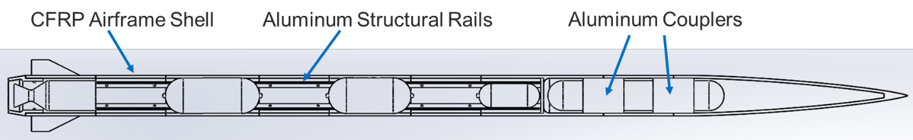

*Figure 10: Structural Configuration Diagram*

*In Flight Forces:*

After the design concept was completed, significant loads experienced by the rocket in flight needed to be determined. The main forces on the rocket in flight are thrust, drag and gravity. If the angle of attack is 0, the airframe sections and rails will be in axial compression, but at non-zero angle of attack, the bending moment becomes important, and the "Max Q" is defined as the max pressure and bending on the vehicle. These loads, as they become more defined, will be used to calculate necessary airframe thickness and to size other structural elements. Some special cases structurally are the thrust bulkhead which secures the engine and can be analyzed as a circular plate centrally loaded, recovery couplers, which need to be sized based on the shock and drag forces of chute deployment, and airframe pressurization, which needs to be accounted for in the recovery bays.

*Calculations:*

The value for thrust is obtained from the design work done on the propulsion system with LOx and Ethanol as propellants and is 2800 N. This is subject to change and won’t be fully known until static fires of the engine are done.

The equation for Maximum Q is given in Eq. 20. Q is time dependent, so Max Q was calculated by plotting Q as a function of time via data from the OpenRocket simulation. Air density (ρ) is not a variable simulated by OpenRocket, so it was calculated using an Earth Atmosphere model published by NASA. This model, shown in Eq. 21, allows for density to be calculated from pressure and temperature, both of which are simulated by OpenRocket.

$Q=\frac{1}{2}∙ρ∙v^{2}$ (Eq. 20)

$ρ=\frac{P}{0.2869∙T}$ (Eq. 21)

After calculating density as a function of time, Q was calculated as a function of time and plotted. The graph is given in *Figure 11*. A maximum Q of 143.2 kPa occurs at burnout (t = 10s). Orbital launch vehicles often experience maximum Q before burnout, but because the max altitude of the rocket is low, the air density does not decrease significantly to the point of outweighing the rate of velocity increase during burn time.

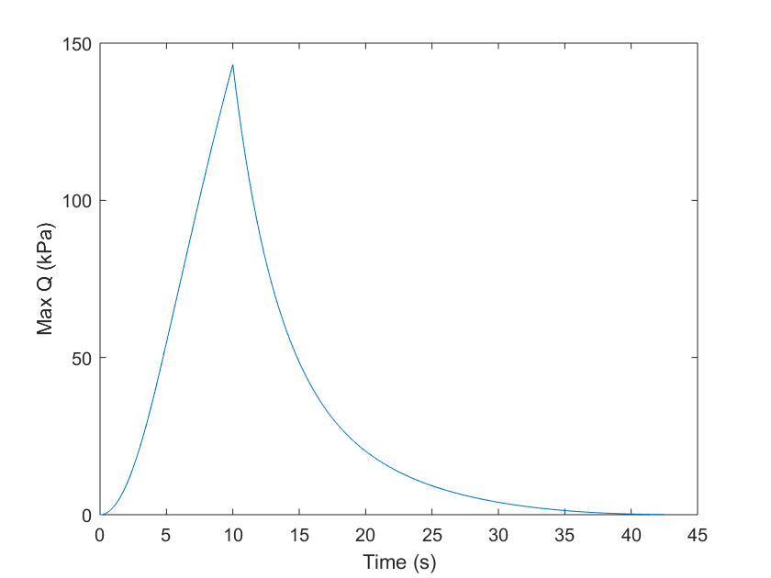

*Figure 11: Max Q plotted as a function of time*

**3.3 Subsystem Design**

Mission subsystem design was outside of the scope of this project but had to be considered for integration and sizing purposes. The systems considered are avionics, recovery, and launch hardware. Airframe sections and structural integration was considered for these systems.

*Avionics:*

Traditional avionics design includes a designated “avionics bay” where all mission electronics can be housed. Based on the sizes of necessary avionics components, the avionics bay has been sized at 12 inches in length. This should be reevaluated when detailed design occurs. Avionics components will be mounted to a plate that will be secured by two threaded rods that go through the couplers at both ends of the avionics bay. A diagram of the setup is given in *Figure 12*.



*Figure 12: Avionics bay diagram [REPLACE WITH CAD]*

*Recovery:*

The recovery system will be dual-bay dual-deployment. A drogue parachute will be housed in the nosecone, with attachment hardpoints in the fore avionics coupler and the nosecone tip. The main chute will be housed aft of the avionics bay, with attachment hardpoints on the aft avionics coupler and the main recovery bulkhead. A diagram of the deployment is given in *Figure 13*.



*Figure 13: Recovery Schematic [REPLACE WITH DIGITAL SCHEMATIC]*

The drogue chute will be deployed at apogee and serve to reduce the rocket’s speed for main chute deployment. The main chute will be deployed at a designated altitude. Both deployments will make use of CO2 gas generators which will pressurize the chute compartments and break shear bolts connecting the airframe/nosecone to the coupler.

*Launch Hardware:*

The rocket will be rail-launched, so launch lugs will need to attach to hard points on the rocket’s structure for launch. Launch lug placement is guided by the general rule that one lug is placed at the wet CG of the rocket and the other is placed somewhere aft of the CG, with enough distance to provide adequate support. Thanks to the semi-monocoque structural method, launch lugs will be attached to structural rails.

**3.4 Simulation Data**

This section documents current rocket weight and dimensioning as well as predicted rocket performance based on the current OpenRocket model in *Table 5*. These performance results are only included for the purpose of documentation, but are very sensitive to the propulsion system, which is still in development. Off-rail velocity and stability are based on a 20 ft launch rail.

*Table 5: Simulation Data*

|  |  |
| --- | --- |
| Diameter (in) | 7 |
| Length (in) | 154 |
| Wet Mass (kg) | 40.8 |
| Dry Mass (kg) | 29.5 |
| Thrust (N) | 2800 |
| Maximum Velocity (ft/s) | 1704 |
| Maximum Acceleration (G) | 6.19 |
| Apogee (ft) | 27620 |
| Off-Rail Velocity (ft/s) | 89.39 |
| Off-Rail Stability (calibers) | 1.663 |

**3.5 Final Preliminary Design**

The current rocket model with relevant dimensions is included. Specific structural dimensions are subject to change as rocket loading becomes more exact. Airframe section lengths are subject to change as internal subsystem dimensions, specifically relating to the propulsion system, become known.

[add drawing package CAD]

**4.0 Manufacturing Analysis:**

Manufacturability was a large consideration in design. All rocket components need to be manufacturable by students at Morgan State with the available tools, or able to be purchased COTS.

**4.1 Airframe**

High powered rockets of this size almost exclusively utilize a composite airframe because composites offer significant weight savings over metallic airframes. Most commonly used composites are Carbon Fiber and Fiberglass. Both are available pre-impregnated with resin, which eases the layup process. Composite airframe sections are most commonly manufactured by laying up the composite on an aluminum mandrel. A mandrel would be purchased or manufactured with outer diameter of the desired inner airframe diameter and then the desired number of layers of composite would be wrapped. The use of mandrels in manufacturing is especially important due to the many airframe sections, necessitating uniformity. Vacuum sealing and/or heating during the drying process are common techniques used to improve airframe strength and quality, which should be investigated.

After manufacturing the airframe shell, fastener holes can be drilled, and any other modifications done to complete the airframe section.

**4.2 Nosecone**

Nosecone’s are typically manufactured with a composite shell and an aluminum tip. As shown in the drawing package, the tip is secured with a washer/bolt assembly that clamps the tip into the composite shell. A similar composite layup process should be used as for airframe sections, but using a 3D printed or machined mold for performing the layup. The surface of the shell edge should be prepared to ensure a good fit with the metal tip.

**4.3 Internal Structures**

Internal structures, including couplers and structural rails are typically manufactured from 6061 Aluminum for its high stiffness to strength and machinability. Machining can be done utilizing CNC milling or manually machined, and more complex structural elements can be made by welding machined pieces.

**4.4 Integration**

The modularity of this design makes structural assembly relatively easy. Care should be taken in fastener placement and attachment points for other subsystems.

**5.0 Tangible Design and Next Steps:**

An important part of design is the ability to show and explain it to others. This was especially important for this project, where students will likely be recruited to the rocketry team in the fall. It is important that they understand the work that has already gone into the project, so they have a good base to work from. To help aid in the necessary knowledge transfer, an additively manufactured model was designed in CAD and 3D printed.

**5.1 Additively Manufactured Model**

The model was designed at a 1:4 scale with thickened airframe walls for printability. The airframe was modeled in a section-view style, where it was were cut in half longitudinally to allow for viewing of internal structural elements and major propulsion system elements. The airframe was modelled in sections that correspond to the sectioning that will be necessary in the actual rocket. An image of the CAD model used for printing is shown in *Figure 14*. Pieces of the model include the nosecone, airframe sections, boattail, couplers, structural rails, helium and propellant tanks, combustion chamber/nozzle, and envelopes of additional subsystems.

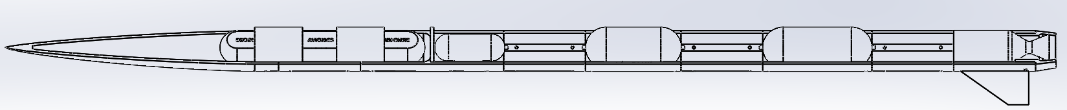

*Figure 14: CAD Model used for 3D Printing Rocket Layout*

The printing was done on two printers: a Makerbot Replicator 2 owned by the MSU Industrial Engineering Department as well as a personally owned Anycubic i3 Mega. The Makerbot printed in yellow PLA and the Anycubic printed in white ABS. A few images from the printing process are shown in *Figure 15*.

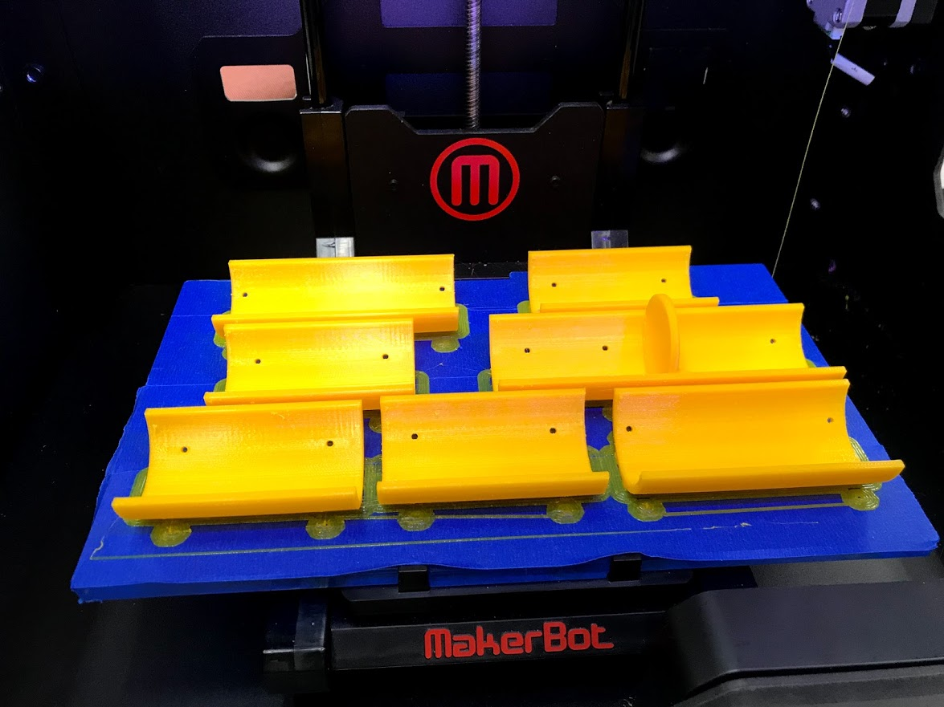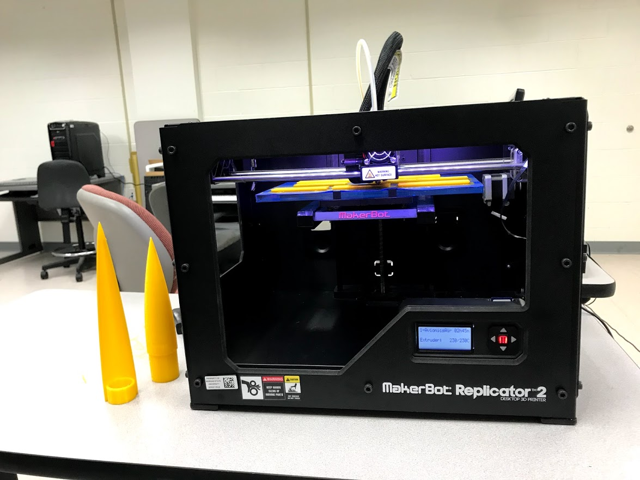

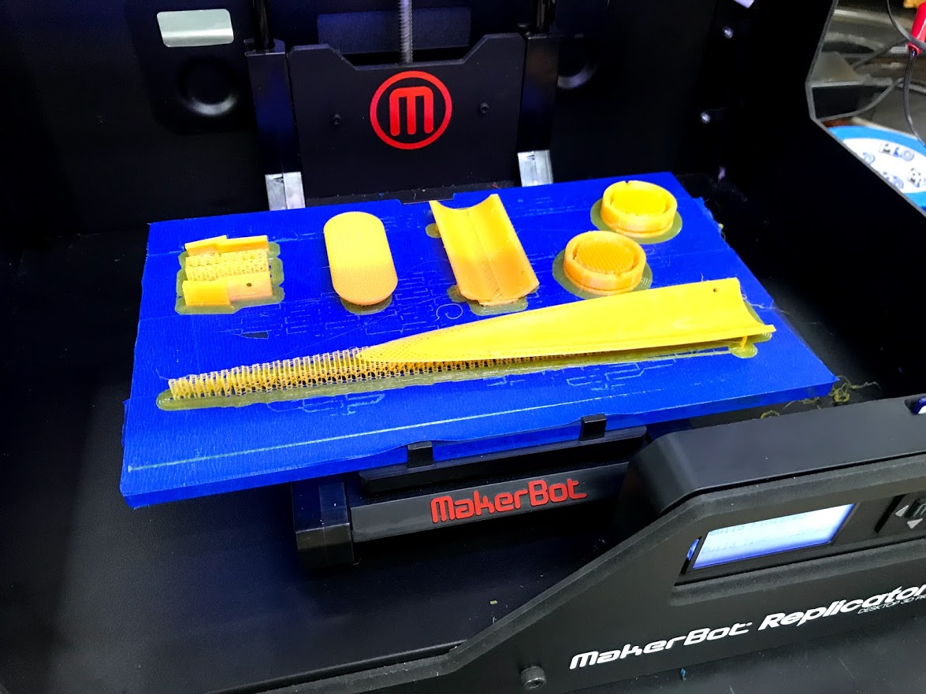

*Figure 15: Printing process*

Additionally, supports were modelled and printed. All components of the rocket were assembled with small #6 3/8” screws, which were hand driven. Pictures of the supports as well as the fully assembled model are shown in *Figure 16*.

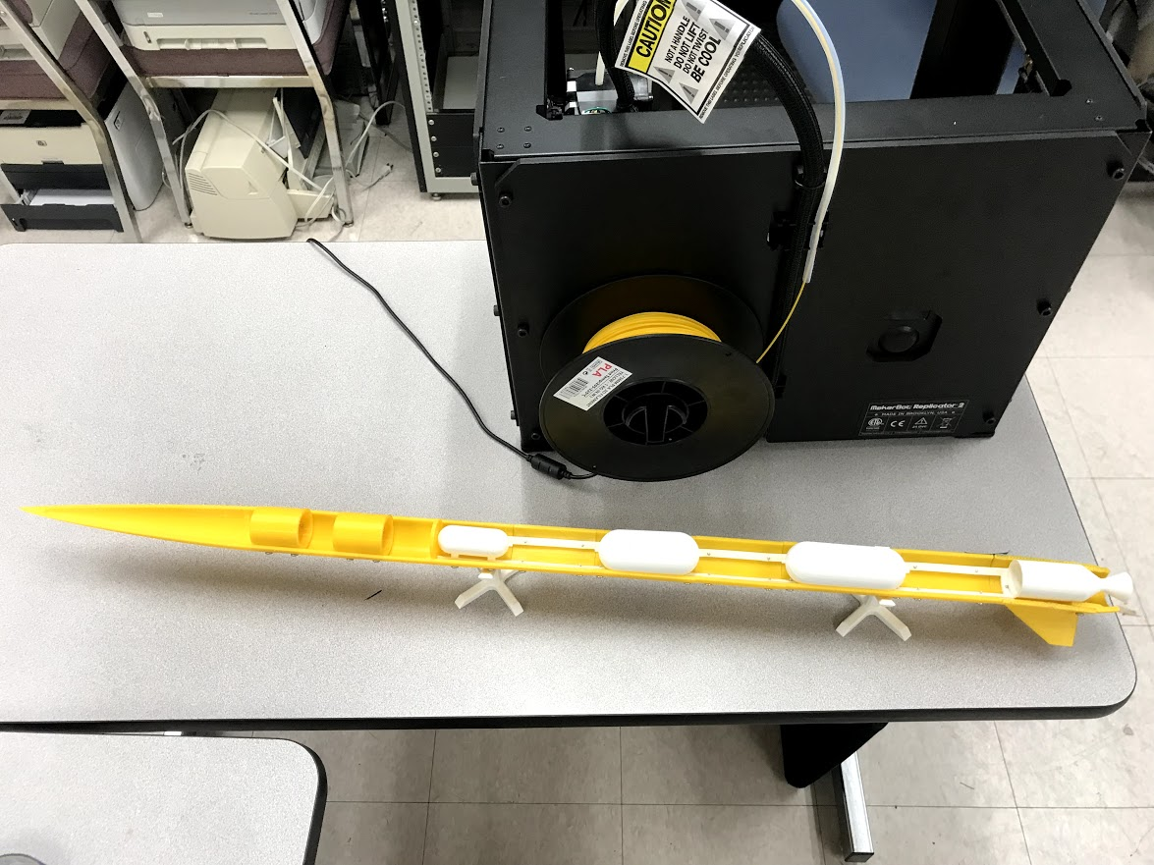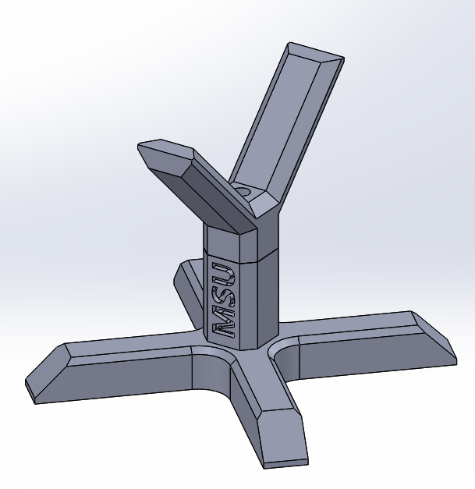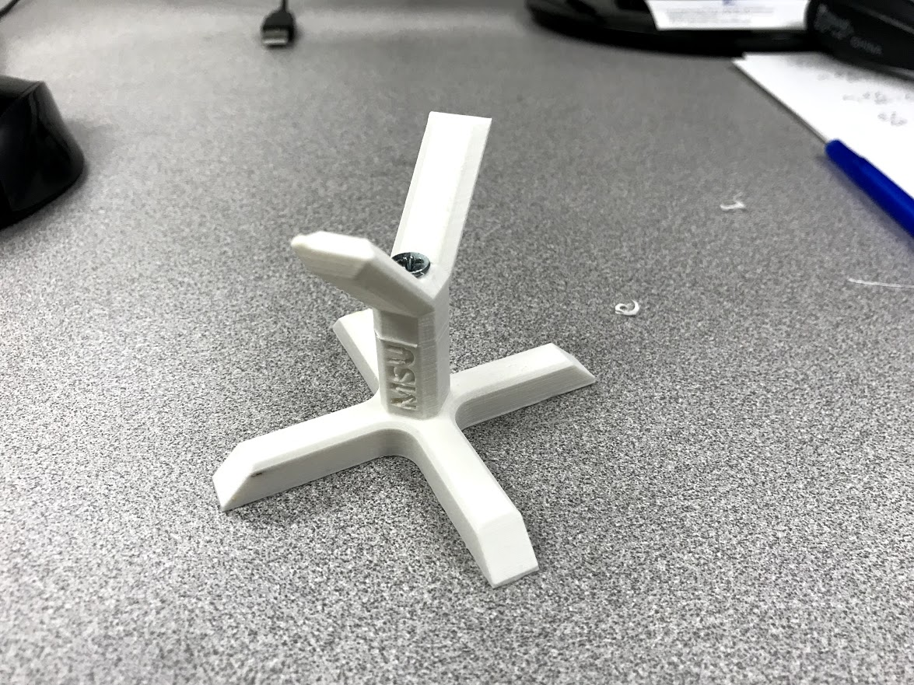

*Figure 16: Fully Assembled Model and support CAD/Print*

**5.2 Future Work**

As previously stated, the purpose of the 3D printed rocket layout model was to have a tangible design to help future students working on this project. Future work on the structural subsystem that should follow the work documented in this report is listed below:

* Integration with the propulsion system – This includes tank coupler attachment points, securing of tank insulation, and engine attachment points.
* Launch lug design and placement
* Structural rail cross section geometry selection
* Airframe material selection, sourcing, and composite layup procedure generation
* Fastener selection

Once static firing of the engine has occurred (which is very far down the road), and thrust characteristics and propulsion geometries are known, specific structural design can take place with couplers, rails, bulkheads, and airframe sections being designed with all necessary hardware attachment points, holes for fasteners, etc. After detail design is complete, these elements should be subjected to more rigorous analysis including FEA.

**6.0 Conclusion:**

Clean sheet rocket structural design is a difficult problem. This project set out to examine preliminary design selection for a liquid propellant rocket with a specific set of design requirements. Design began by setting optimization goals and establishing criteria to achieve those goals. Then, initial sizing was completed using case study data from comparable rockets, simulation in OpenRocket, and early propulsion data. A method for trajectory simulation based on the limited propulsion data available was constructed in Python. Then, a conceptual design configuration was selected, including the positioning of internal subsystems.

In preliminary design, the rocket shape was established through aerodynamic analysis on several nosecone and fin configurations and a boattail was incorporated into the design to reduce base drag. Then, work was done to determine the in-flight loading of the rocket. A structural design method was selected, and basic sizing of main structural components was completed based on the loading. The avionics and recovery subsystems were considered in low-level detail. Current flight simulation data was included as well as drawings of the current design. Finally, manufacturing was briefly discussed, and documentation of the 3D printed structural layout model was included with a discussion of future work for this project.

**Acknowledgments**

This project was possible thanks to the guidance of mentors Dr. Guangming Chen and Dr. Richard Damoah, funding by the Maryland Space Grant Consortium, and support by Gregory Patton.



**Bibliography**

[1] “Design Optimization of the LV4 Sub-orbital Rocket,” *Jupyter Notebook Viewer*. [Online]. Available: https://nbviewer.jupyter.org/github/psas/liquid-engine-analysis/blob/master/optimization/previous_work/LV4_Optimization.ipynb. [Accessed: Jul-2019].

[2] M. D. Griffin and J. R. French, *Space Vehicle Design (2nd Edition).* American Institute of Aeronautics and Astronautics, 2004.

[3] E. M. Marconi, “What is a Sounding Rocket?,” *NASA*. [Online]. Available: https://www.nasa.gov/missions/research/f_sounding.html. [Accessed: 06-Jun-2019].

[4] D. Akin, “Structural Design and Analysis,” 2014. [Online]. Available: https://spacecraft.ssl.umd.edu/academics/483F14/483F14L21.structural_design/483F14L21.struc_designx.pdf. [Accessed: 12-Jul-2019].

[5] N. Bergey, “PSAS Liquid Engine Analysis,” *GitHub*, 30-Oct-2014. [Online]. Available: https://github.com/psas/liquid-engine-analysis/blob/master/delta-v-estimations/fake-liquid-motor.py. [Accessed: 02-Jul-2019].

[6] R. Nakka, “Rocket Body Structural Strength,” *Richard Nakka's Experimental Rocketry Site*. [Online]. Available: http://www.nakka-rocketry.net/fusestru.html. [Accessed: 10-Jul-2019].

[7] G. P. Sutton and O. Biblarz, *Rocket propulsion elements*. Hoboken (N.Y.): Wiley., 2017.

[8] A. Datye and S. Zaidi, “Fin Optimization for Enhanced Flight Performance of an Experimental Rocket,” *NCUR*, Apr. 2018.

[9] J. S. Barrowman, *The practical calculation of the aerodynamic characteristics of slender finned vehicles*. Washington, D.C.: National Aeronautics and Space Administration, 1967.

[10] T. Benson, “Earth Atmosphere Model - Metric Units,” *NASA*, 12-Jun-2014. [Online]. Available: https://www.grc.nasa.gov/WWW/K-12/rocket/atmosmet.html. [Accessed: 31-Jul-2019].

[11] G. Stroick, “Nose Cone & Fin Optimization,” *Off We Go Rocketry*, Jan-2011. [Online]. Available: http://www.offwegorocketry.com/userfiles/file/Nose Cone & Fin Optimization.pdf. [Accessed: Jul-2019].

[12] “Concordia's First Supersonic Sounding Rocket,” *Experimental Sounding Rocket Association*. [Online]. Available: http://www.soundingrocket.org/uploads/9/0/6/4/9064598/79_project_report.pdf. [Accessed: Jun-2019].

[13] *DSC02896*. SEDS UCSD, 2016.

**APPENDIX A**

C:\Users\mniss\Desktop\Sim>enginesim.py

Manufacturer: ARROW

Propellant Tank Radius (in): 3

Helium Tank Radius (in): 3

Tank Pressure (MPa): 3.42

Helium Tank Pressure (MPa): 18

Tank thickness: 1.42 mm

Helium Tank thickness: 7.45 mm

Rocket Code: LOXETH

Oxidizer options: dict_keys(['LOX', 'FLOX', 'LF', 'N2O4'])

Oxidizer: LOX

Fuel options: dict_keys(['RP1', 'METH', 'ETH', 'LH2', 'UDMH'])

Fuel: ETH

Specific Impulse (s): 253.1

O/F Ratio: 1.3

Thrust (N): 2800

Burn Time (enter as list separated by spaces): 8 10 12

Total Propellant Mass: 9.02 kg

Ox mass: 5.10 kg

Fuel mass: 3.92 kg

Mass flow: 1.13 kg/s

Ox flow: 0.64 kg/s

Fuel flow: 0.49 kg/s

Helium tank length: 11.428 in

Ox tank length: 10.120 in

Fuel tank length: 11.241 in

System length: 81.018 in

Ox tank mass: 0.60 kg

Fuel tank mass: 0.65 kg

Helium tank mass: 3.26 kg

Dry Mass: 12.5 kg

Dry CM: 1.064 m

Total impulse: 22400 N.s

NAR: "O" (55%)

Total Propellant Mass: 11.28 kg

Ox mass: 6.38 kg

Fuel mass: 4.90 kg

Mass flow: 1.13 kg/s

Ox flow: 0.64 kg/s

Fuel flow: 0.49 kg/s

Helium tank length: 14.110 in

Ox tank length: 12.623 in

Fuel tank length: 14.024 in

System length: 88.984 in

Ox tank mass: 0.72 kg

Fuel tank mass: 0.78 kg

Helium tank mass: 3.88 kg

Dry Mass: 13.4 kg

Dry CM: 1.151 m

Total impulse: 28000 N.s

NAR: "O" (68%)

Total Propellant Mass: 13.54 kg

Ox mass: 7.65 kg

Fuel mass: 5.89 kg

Mass flow: 1.13 kg/s

Ox flow: 0.64 kg/s

Fuel flow: 0.49 kg/s

Helium tank length: 16.792 in

Ox tank length: 15.125 in

Fuel tank length: 16.806 in

System length: 96.951 in

Ox tank mass: 0.83 kg

Fuel tank mass: 0.91 kg

Helium tank mass: 4.51 kg

Dry Mass: 14.2 kg

Dry CM: 1.235 m

Total impulse: 33600 N.s

NAR: "O" (82%)

Type 'y' to enter a new Engine, type 'n' to finish: n

Reopen OpenRocket to run simulation